CLASSIFIED READING

FRUITS

|  |
| --- |
| Banana On White Background HD Stock Images | Shutterstock  Banana |

|  |
| --- |
|  |

1. BANANA

**2. APPLE**

**3. POMEGRANATE**

**4. STRAWBERRY**

**5. PEAR**

**6. MANGO**

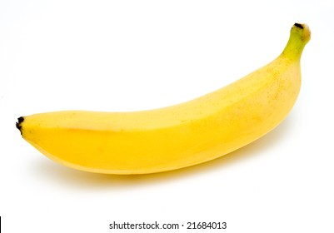

|  |
| --- |
| Banana |